OCEANA COUNTY

**4-H SMALL MARKET**

**TURKEY RECORD BOOK- 2024**

**(for ages 8 and up)**

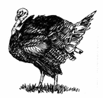

As a member of the Small Market Animal Project, you are required to submit your records as part of an educational project notebook in order to show your animal at the Oceana County Fair. **This notebook must be shown to the Poultry Superintendent or designated Small Market Weighmaster at the time of weigh-in and then entered by you in the Educational Notebook Division at the Oceana County Fair on Entry Day.**

**AGE: ___________**

The age you enter depends on how old you were on January 1, 2024

**NUMBER OF YEARS IN PROJECT: _____________**

Use this page as the first page of your project record book. Fill it out completely.

**Please print or type neatly**.

# NAME ______________________________________________________________________

**4-H CLUB ___________________________________________________________________**

##### LEADER _____________________________________________________________________

**DATE RECORDS STARTED ____________________ DATE ENDED __________________**



**JUDGE’S SCORE/COMMENT SHEET**

**(PLEASE DO NOT REMOVE, PLACE THIS SHEET IN SHEET PROTECTOR OR GLUE TO COVER). This sheet must be keep free to the judge to write their comments.**

This sheet should help each 4-H’er understand their ribbon placing.

A. **Specific educational value or worth**

___ All questions were answered completely

___ All calculations were correct

___ Calculations were incorrect

___ Questions were not completely answered

___ Questions were not answered (missed questions)

B. **Notebook contains all project records**

___ Notebook contained all project records and were fully completed

___ Notebook contained additional project related information (research

materials etc.)

___ Project records were incomplete

___There was no additional project related information

C. **Accuracy, neatness and general appearance**

___Notebook was neat in appearance (typed/hand printed)

___ Notebook pages were clean and stain free

___Notebook pages were in order and complete

___Notebook pages were out of order and missing pages

___Notebook was difficult to read and messy

___Notebook had wrinkled and stained pages

Other Comments: _____________________________________________________________________________________

_____________________________________________________________________________________

_____________________________________________________________________________________

2024- SMA TURKEYS PAGE 2

## OBJECTIVES

1. Develop desirable work habits, sportsmanship, and ability to cooperate and express ideas through participation in projects, discussions, method demonstrations, judging teams, and exhibits.
2. Experience the pride and responsibility of leasing/owning and caring for poultry.
3. Learn how to feed, fit, show, breed and raise poultry.
4. Learn proper handling procedures to prevent injuries to 4-H members and their poultry projects.
5. Appreciate and use scientific information in poultry production and marketing.
6. Improve knowledge of grading, marketing and merchandising of poultry and poultry products.
7. Improve knowledge of the nutritive value of poultry meat and eggs and how they contribute toward good health.
8. Learn the importance of the poultry industry to the local, state, and national economies.
9. Acquire information on the opportunity that poultry offers as a career.

This record book is part of your Small Market Turkey project. By keeping records up-to-date you will be able to see how much progress you make as you set Goals and work to accomplish them. Write or type neatly and clearly. Please keep the pages in order. Feel free to add extra pages at the end of your notebook.

SCORING CRITERIA

The following breakdown will be used during the judging process of all market livestock notebooks:

A. Specific educational value or worth **30%**

B. Creative way of showing what has been learned **10%**

C. Notebook contains all project records **50%**

D. Accuracy, neatness and general appearance **10%**

The Oceana County 4-H Small Market Animal Committee encourages 4-H Leader and parent assistance with your project and project notebook. If you should have any questions, please contact the MSU Extension Office.

**If you needed extra help in filling out your notebook** please have whoever helped sign below that the answers are YOUR answers and that they assisted you in the writing of the answers and understanding of the questions only.

***(signature of person helping with writing if needed)***

2024- SMA Turkeys PAGE 3

**JOURNAL OF CARE**

The SMAA Committee would like the judge to see the time and effort which you put into the care & management of your project.

Include the following:

* Feeding and watering practices
* Health practices and medicines (vaccinations, etc.)
* General Management (building a cage, cleaning living area, feed pans, etc.)

|  |
| --- |
| **DAILY- Things done once or twice a day** |
|  |
| **WEEKLY- Things done once or twice a week** |
|  |
| **MONTHLY- Things done once a month** |
|  |
| **YEARLY- Things done one time or occasionally throughout the year** |
|  |

2024- SMA TURKEYS PAGE 4

**Describe the type of turkeys being used in this project. List breed and variety. Why did you choose this breed?**

______________________________________________________________________________

______________________________________________________________________________

______________________________________________________________________________

______________________________________________________________________________

______________________________________________________________________________

## WEIGHT CHART

|  |  |  |
| --- | --- | --- |
| Date | Age | **Weight** |
|  |  |  |
|  |  |  |
|  |  |  |
|  |  |  |
|  |  |  |
|  |  |  |

**FINAL WEIGHT (FW)___________ AGE__________ DATE___________**

***\*Final weight may need to be estimated depending on Covid 19 restrictions***

2024- SMA TURKEYS PAGE 5

## EXPENSES

##### (A) Cost of poults $_______________________

|  |  |  |  |
| --- | --- | --- | --- |
| **DATE** | LBS. OF FEED | FEED - VARIETY | COST |
|  |  |  | **$** |
|  |  |  |  |
|  |  |  |  |
|  |  |  |  |
| **(B)** |  | **TOTAL SPENT ON FEED** | **$** |

|  |  |  |
| --- | --- | --- |
| **DATE** | OTHER EXPENSES, VET, SUPPLIES, HOUSING, ETC. | COST |
|  |  | **$** |
|  |  |  |
|  |  |  |
|  |  |  |
| **(C)** | **TOTAL SPENT ON OTHER EXPENSES** | **$** |

##### GRAND TOTAL OF ALL EXPENSES (TE): $ _______________________

**(total of A+B+C)**

**_______________ ÷ _________________ = ______________________________________**

Total Expenses **(TE)** Final Weight **(FW)** Break Even Price **(BE)**

(total cost per pound to raise your animal)

***\*\* The breakeven price is the price that you need to get at the***

***Small Market animal auction in order to not lose money on your market project \*\****

2024- SMA TURKEYS PAGE 6

**MARKETING**

One of the most important parts of any market animal project is marketing; this is how you get someone to come to the auction to buy your animal. It may include things such as writing letters and talking to possible buyers.

* What did you do to market your animal?
* If you had a market project in the past what did you do differently this year?

_____________________________________________________________________________

_____________________________________________________________________________

______________________________________________________________________________

______________________________________________________________________________

**FEATHER PATTERNS**- write the name of the pattern under the correct feather

MOTTLED PENCILED

LACED

STRIPED

SPANGLED

BARRED

2024- SMA TURKEYS PAGE 7

**READING A FEED LABEL**

**USING THE FEED LABEL ON THE LEFT ANSWER THE FOLLOWING QUESTIONS**

1. What is the main ingredient in this

feed?

_______________________________

2. What is the active ingredient?

_________________________________

3. What is the crude protein level?

_________________________________

4. How many days prior to slaughter

should this feed be removed?

________________________________

5. This should be the only ration fed

to starting poults of what age:

_________________________________

6. Is this feed medicated? _________

7. What does this feed help prevent?

_________________________________

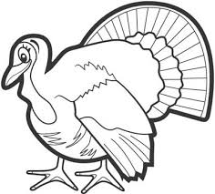

2024- SMA TURKEYS PAGE 8

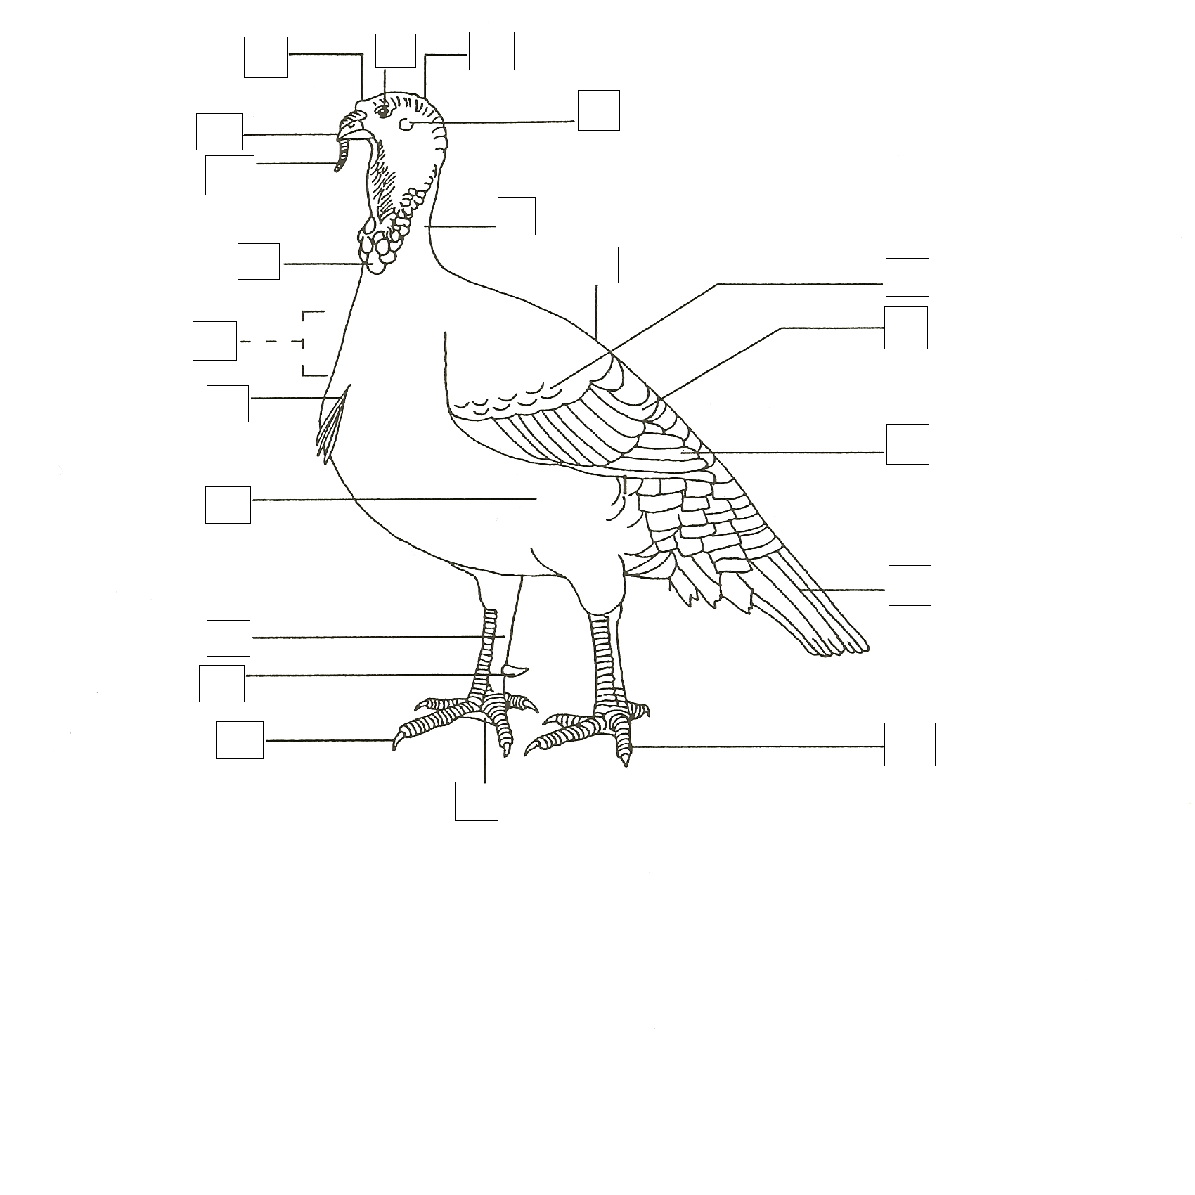

**IDENTIFY THE PARTS OF THE TURKEY**

(fill in the boxes in the above picture with the letter corresponding to the correct part)

1. SECONDARY WING FEATHERS H. CARUNCLE O. PRIMARY WING FEATHER
2. TOENAIL I. EYE P. COVERTS
3. FOOT J. SHANK Q. BACK
4. BEAK K. SNOOD R. FOREHEAD
5. CROP AREA L. EAR S. THIGH AREA
6. BEARD M. NECK T. SPUR
7. CROWN N. TAIL FEATHERS U. TOE

2016- SMA TURKEYS PAGE 7

2024- SMA TURKEYS PAGE 9

**DIGESTIVE SYSTEM OF POULTRY**

Courtesy of Kansas State 4-H Poultry Leader Notebook

2024- SMA TURKEY PAGE 10

**THE HEALTH OF YOUR BIRDS**

Fill in the chart below with what a healthy bird would look or act like and also

an unhealthy bird (see the example).

|  |  |  |  |
| --- | --- | --- | --- |
| **APPEARANCE** |  | ***A HEALTHY BIRD*** | ***AN UNHEALTHY BIRD*** |
|  | **FEATHERS** |  |  |
|  | **EYES** |  |  |
|  | **POSTURE** |  |  |
| **BEHAVIOR** |  |  |  |
|  | **EATING** |  |  |
|  | **DRINKING** |  |  |
|  | **SOUNDS** | *(example) Normal bird sounds. No coughing, sneezing, rattles or other sounds when breathing.* | *Sneezing, sheezing, coughing, rattles, creaks, graons, clicks, snaps or other sounds.* |

2024- SMA TURKEY PAGE 11

**MATCH THE WORD TO THE CORRECT DEFINITION**

**(write the corresponding letter in the space provided)**

_____ Embryo A. The process by which a chick comes out of the egg

_____ Hen B. The portion of the leg between the hock joint and

the toes

_____ Hock C. The developing bird within the egg

_____ Snood D. A bird’s body structure

_____ Poult E. Male and female of the same variety

_____ Shank F. A tube-like fleshy growth near the front of the top of

the head of turkeys

_____ Molt G. A female turkey

_____ Caruncles H. A male turkey

_____ Carriage I. Joint between lower leg and shank

_____ Gizzard J. The reddish fleshy growth on portion of the head

and neck of a turkey

_____ Hatch K. Young turkey of either sex

_____ Conformation L. An organ that contains grit for grinding up the grain

Eaten

_____ Beak M. The posture of the bird

_____ Tom N. The process of shedding old feathers & growing new

_____Pair O. The horny mouth parts of turkeys

2024- SMA TURKEYS PAGE 12

**PROJECT PROGRESS AND MANAGEMENT REPORT**

1. What did you enjoy doing the most with your project? ­_______________________

_______________________________________________________________________________

______________________________________________________________________________

_______________________________________________________________________________

2. What was the hardest part of your project?___________________________________

_______________________________________________________________________________

_______________________________________________________________________________

_______________________________________________________________________________

3. Will you do the market poultry project again? ____________________

Why or Why not? ___________________________________________________________

_______________________________________________________________________________

_______________________________________________________________________________

4. Would you recommend the breed that you chose for a market project? _______

Why or Why not? ___________________________________________________________

_______________________________________________________________________________

_______________________________________________________________________________

2024- SMA TURKEYS PAGE 13

**The 4-H Pledge**

(fill in the blanks)

***I Pledge:***

My HEAD to clearer _______________________________________,

My HEART to greater ______________________________________,

My HANDS to larger _______________________________________, and

My HEALTH to better ______________________________________,

For my ______________________________, my __________________________________,

My _________________________________, and my ______________________________.

The 4-H Mottos is: _________________________________________________________________.

**FIND, AND CIRCLE, THE FOLLOWING “4-H” WORDS IN THE PUZZLE BELOW**

|  |  |  |  |  |  |  |  |  |  |  |  |  |
| --- | --- | --- | --- | --- | --- | --- | --- | --- | --- | --- | --- | --- |
| W | E | T | H | E | P | E | O | P | L | H | I | N  **WORD BANK:**  **CARING**  **CHARACTER**  **CITIZENSHIP**  **COMMUNITY**  **GIVING**  **HANDS**  **HEAD**  **HEALTH**  **HEART**  **HONESTY**  **INTEGRITY**  **RESPECT**  **SPORTSMANSHIP**  **TRUST**  **TRUTH** |
| O | S | R | D | R | E | T | C | A | R | A | H | C |
| T | P | O | R | M | F | O | R | G | A | N | M | I |
| B | O | P | E | B | P | U | O | N | L | D | M | T |
| T | R | U | S | T | K | C | W | I | E | S | R | I |
| B | T | M | P | N | Z | G | W | V | S | P | I | Z |
| N | S | W | E | O | L | V | E | I | H | R | I | E |
| E | M | S | C | A | R | I | N | G | O | S | P | N |
| A | A | R | T | Y | W | M | O | Z | N | S | H | S |
| G | N | F | E | T | T | O | D | A | E | H | N | H |
| T | S | E | R | I | M | A | R | I | S | E | V | I |
| R | H | W | T | H | V | E | R | S | T | R | C | P |
| W | I | N | T | E | G | R | I | T | Y | H | U | E |
| E | P | O | B | A | L | I | C | R | E | N | W | A |
| D | D | P | H | R | K | I | L | O | R | I | C | L |
| H | E | A | L | T | H | M | J | C | H | A | W | R |
| N | Q | L | J | Y | T | I | N | U | M | M | O | C |

2024- SMA TURKEYS PAGE 14

**MY 4-H STORY**

(Interesting things that happened to me and my animal this year, challenges, highlights of my year or anything else I would like to share about my

overall 4-H experience)

***POTENTIAL BUYERS NAMES***

As part of your 4-H Small Market Livestock Project, you must personally contact at least three potential buyers before the Oceana County Fair. You are encouraged to seek two new buyers that have not been asked or submitted before. **You also must have at least three different buyers than those of your siblings in the market livestock project.** Please confirm with your buyers their accurate mailing address (example: post office box vs. a street address). The information on page 15 must be completed and taken to the Oceana County MSU Extension Office on or before the due date where it will be **copied** and used to send out letters to your potential buyers. This page will remain in your notebooks. This is a Market Livestock Committee rule. Failure to comply will result in not being able to sell your animal in the 4-H Market Livestock Sale.

2024- SMA TURKEYS Date: _______________

Page 15 Staff: _______________

**SMAA/ JUNIOR MARKET POTENTIAL BUYER’S LIST**

**TURKEY PROJECT (AGES 8 & up))**

Name______________________________ Club_________________________

***Please print business names and complete addresses clearly.***

* 1. Contact Name ________________________________________________­­____

Business Name ____________________________________________________

**Mailing** Address _________________________City__­­­­­­­­__­­­­­­­_____________Zip_____

Phone _______________________ After Hours Phone______________________

Mailing Preference (Please Check One): Email ____ Postal Delivery ____

Email ____________________________________________________________

Signature__________________________________________________________

2. Contact Name ________________________________________________­­____

Business Name ____________________________________________________

**Mailing** Address _________________________City__­­­­­­­­__­­­­­­­_____________Zip_____

Phone _______________________ After Hours Phone______________________

Mailing Preference (Please Check One): Email ____ Postal Delivery ____

Email ____________________________________________________________

Signature__________________________________________________________

3. Contact Name ________________________________________________­­____

Business Name ____________________________________________________

**Mailing** Address _________________________City__­­­­­­­­__­­­­­­­_____________Zip_____

Phone _______________________ After Hours Phone______________________

Mailing Preference (Please Check One): Email ____ Postal Delivery ____

Email ____________________________________________________________

Signature__________________________________________________________

(Must be stamped by the MSU Extension Office)

2024- SMA TURKEYS PAGE 16

**PICTURES OF YOUR PROJECT**

(Please use this page for your project pictures. Add additional pages if you would like. The judges appreciate you labeling the pictures so they know what the picture shows.)

**CLUB POINTS**

**JUNIOR MARKET/SMALL ANIMAL ASSOCIATION PROJECT**

**ATTENDANCE RECORD**

|  |  |  |  |  |
| --- | --- | --- | --- | --- |
| **MEETING NAME** | **LOCATION** | **DATE** | **POINTS** | **SIGNATURE OF LEADER** |
|  |  |  |  |  |
|  |  |  |  |  |
|  |  |  |  |  |
|  |  |  |  |  |
|  |  |  |  |  |
|  |  |  |  |  |
|  |  |  |  |  |
|  |  |  |  |  |
|  |  |  |  |  |
|  |  |  |  |  |
|  |  |  |  |  |
|  |  |  |  |  |

**Please note:** This form must be included with your record notebook and turned into the weigh master on entry day of the Fair. You need to accumulate **nine (9)** points to be allowed to sell your animal. **Six (6)** of these nine (9) points must come from club meetings. **Three (3)** nonclub points must come from other types of meetings (example: clinics, shows, workshops, fair clean-up and/or county-wide awards).

# *NON-CLUB* POINTS

**JUNIOR MARKET/SMALL MARKET ANIMAL ASSOCATION PROJECT**

**ATTENDANCE RECORD**

***(this must be filled out when presenting for signatures at the office)***

|  |  |  |  |  |
| --- | --- | --- | --- | --- |
| **MEETING NAME** | **LOCATION** | **DATE** | **POINTS** | **SIGNATURE OF LEADER, SUPERINTENDENT OR MSU STAFF** |
|  |  |  |  |  |
|  |  |  |  |  |
|  |  |  |  |  |
|  |  |  |  |  |
|  |  |  |  |  |
|  |  |  |  |  |
|  |  |  |  |  |
|  |  |  |  |  |
|  |  |  |  |  |
|  |  |  |  |  |

**Please note:** This form must be included with your record notebook and turned into the weigh master on entry day of the Fair. You need to accumulate **nine (9) points** to be allowed to sell your animal. **Six (6)** of these nine (9)pointsmust come from club meetings. **Three (3)** nonclub points must come from other types of meetings (example: clinics, shows, workshops, fair clean-up and/or county-wide awards).